DBA | Implementation of the FRP Application
Implementation Guide

Table of Contents
1. IMPLEMENTATION 3
1.1. Backup 3
1.2. Deployment Proper 3
1.3. Rollback (Optional – in case of failed deployment) 4
2. Test / Verification 4

INTRODUCTION

Implementation

Backup
Not applicable

Deployment Proper

- Connect to FRP PROD Database Server (RSRSPW22DVM01 / 172.25.189.10)
- OPEN SSMS (SQL Server Management Studio)
- Execute below script to create the FRP Database.

For Uni:

CREATE DATABASE FRP_UNI
GO

For RB:

CREATE DATABASE FRP_RB
GO

- Restore Database Backup

TFS path: \\ewbtfsappsm01\ITG-TFS\SDD1\OneSumX\PROD\FRP DB Objects\Initial Deployment 11.11.2026

No. | Database | Database File Name
1 | FRP_UNI | FRP_UNI_111126.bak
2 | FRP_RB | FRP_RB_111126.bak

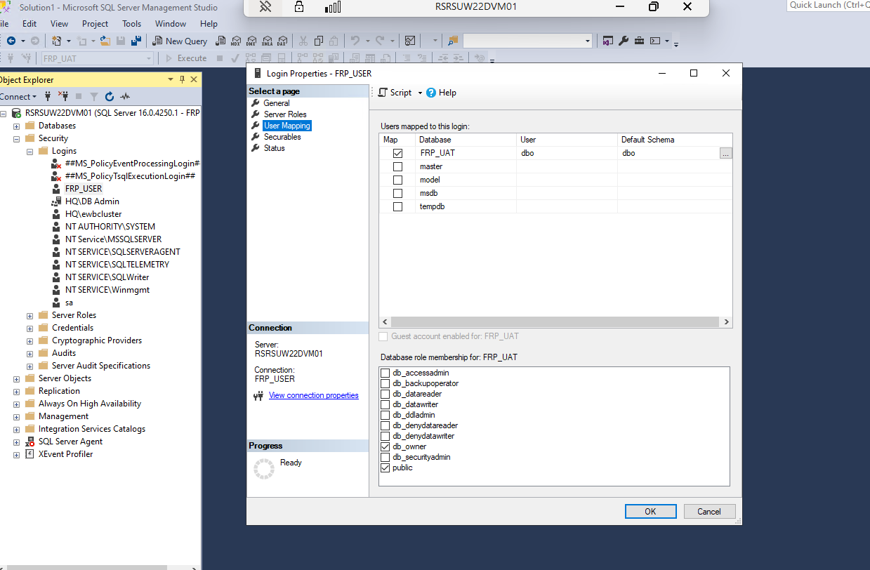
- Double check if the frp_db_user already mapped to FRP_UNI and FRP_RB Database

Rollback (Optional – in case of failed deployment)

- Drop/Delete new FRP database.

Test / Verification

- New FRP database is successfully created.
- Run the FRP application, should not have error while running:
- Scan
- Validation
- XML Conversion

